**REPORT ON RADISSON HOTEL**

**INTRODUCTION:**

* We first watch the course videos with helped us with the project. Working with tableau to analyze the data of Radisson hotels was a different experience. We create empathy map it helps to known more information about the hotel. Then we create a brainstorming in that we discuss about customers satisfaction, customer service, increasing the customer count in hotel and hour to improve hotel facilities. We had many ideas to increase quality and services.

**PURPOSE :**

* It can help the hotel growth, better decision making, improving the customers services, popularity. It can also help to improve the overall development. By using guest experience . we can easily analyze the satisfaction of the customer.

PROMBLEM DEFINITION & DESIGN THINKING :

**EMPATHY MAP :**

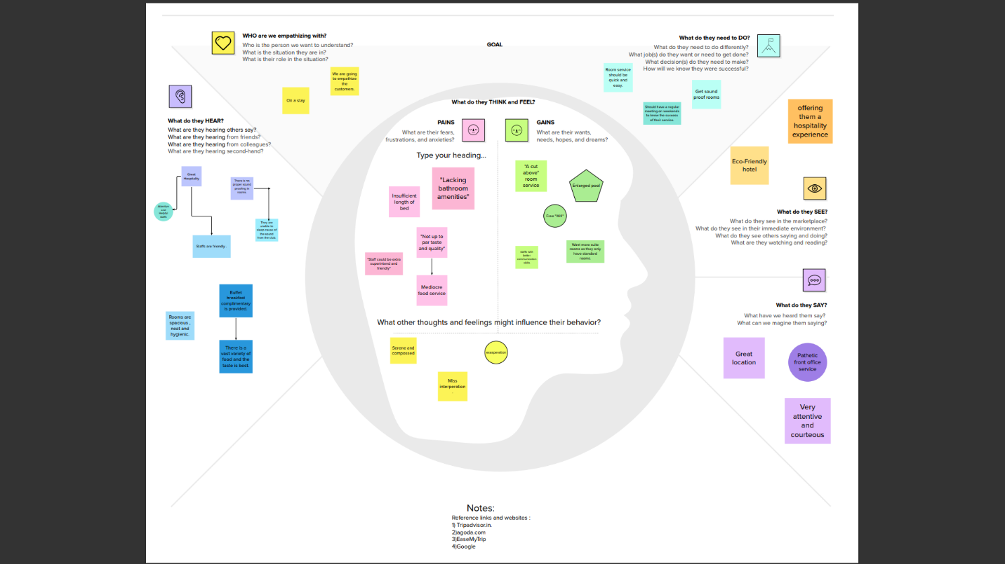

**BRAINSTROMING:**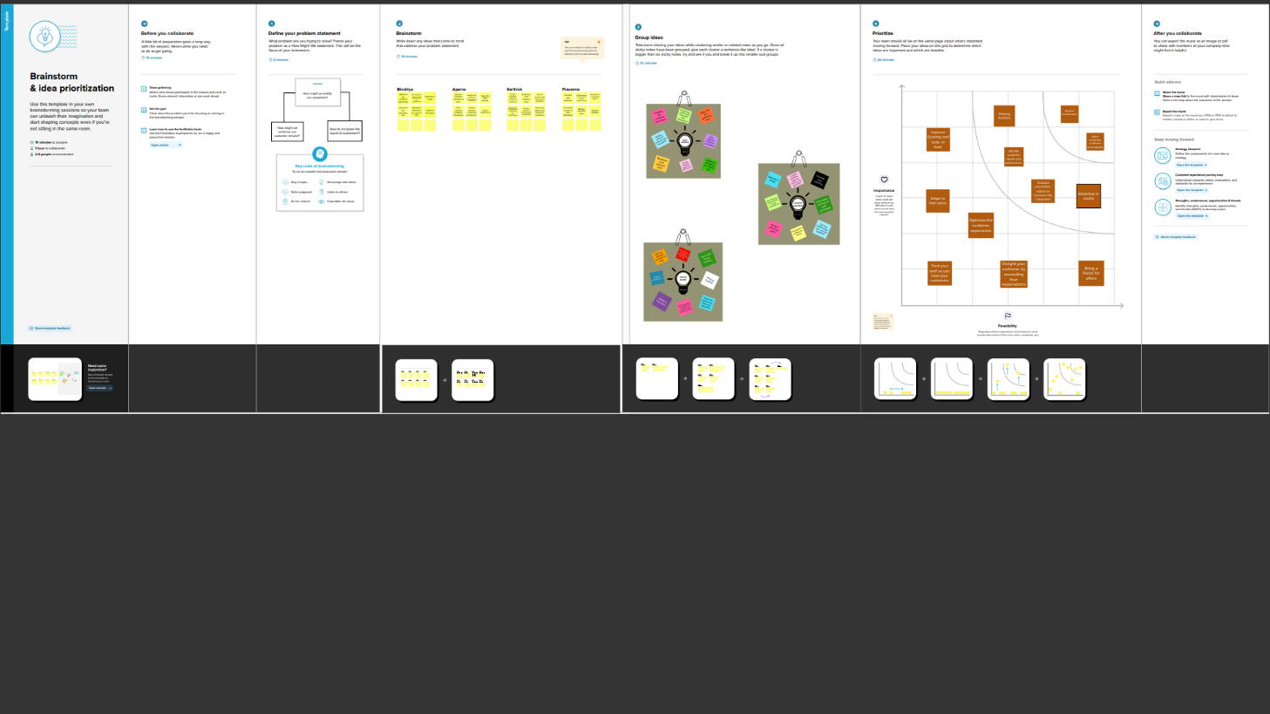

**RESULT:**

**DASHBOARDS& STORIES:**

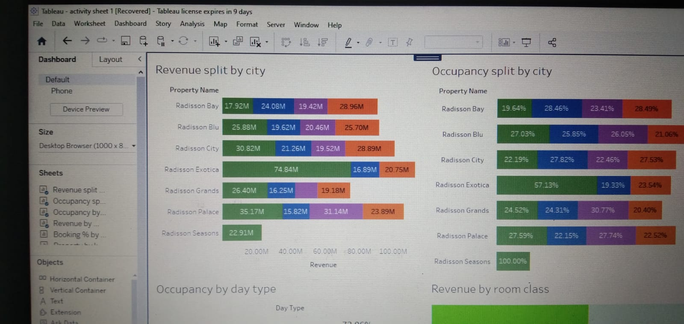

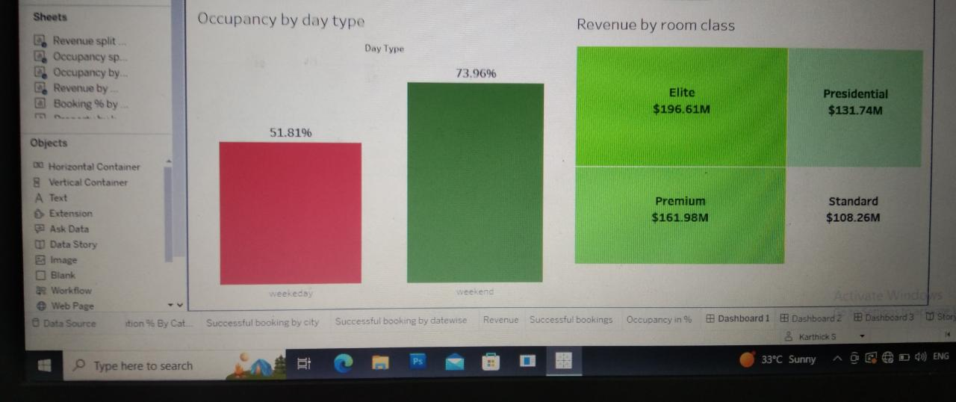

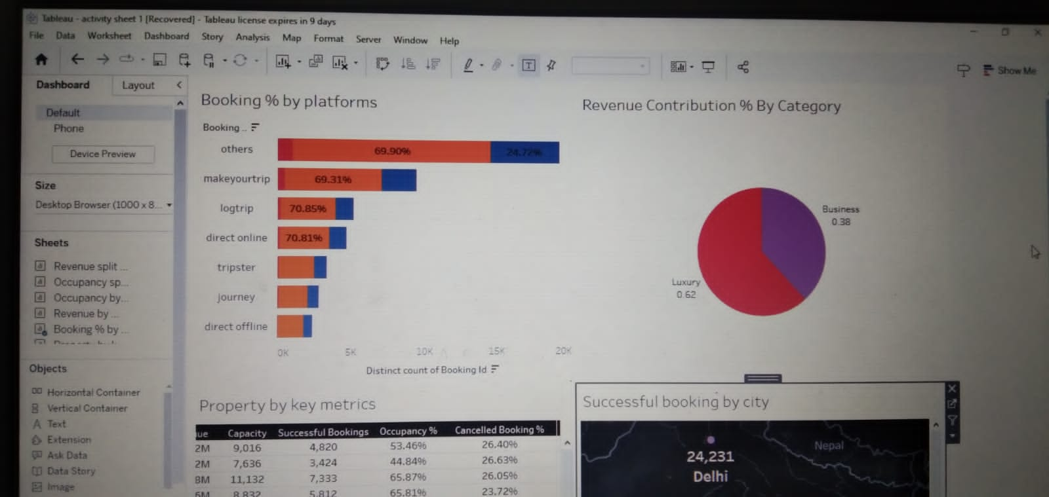

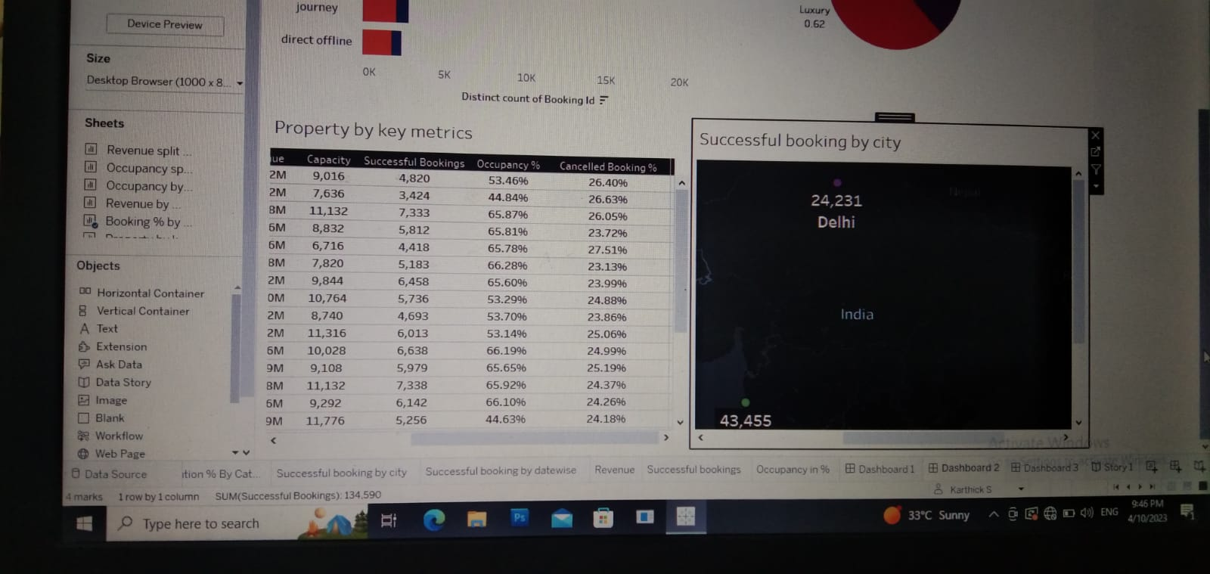

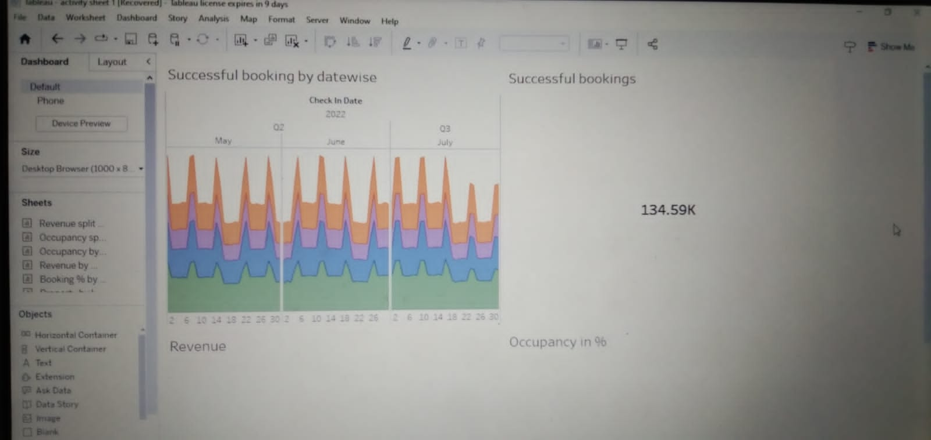

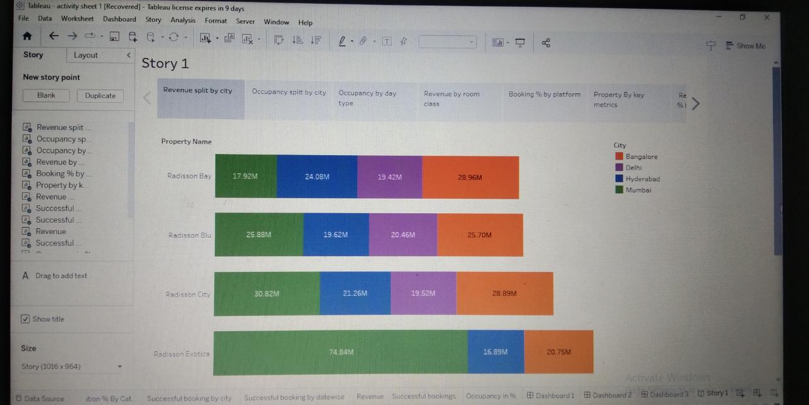

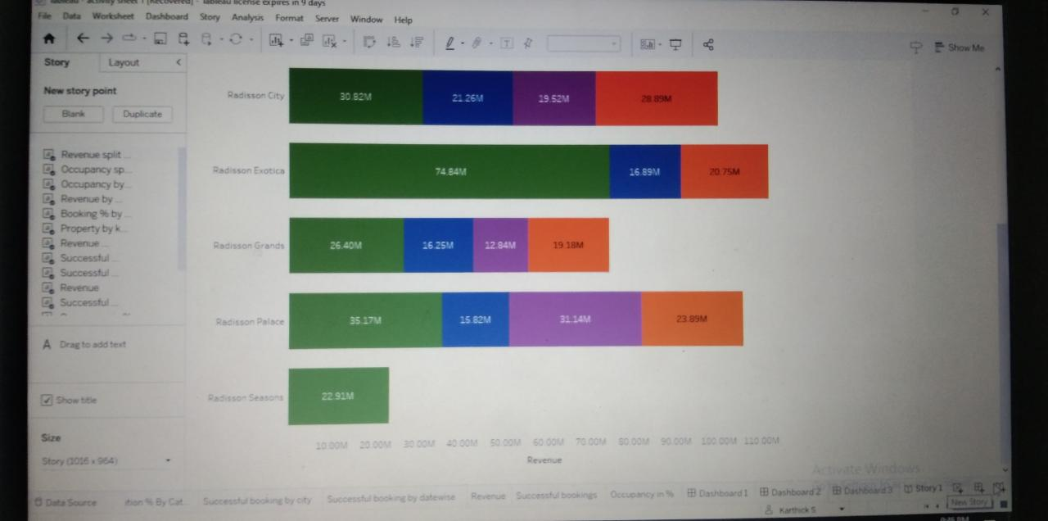

**ADVANTAGES & DISADVANTAGES:**

* In this analysis we enriched the devalued qualities and services of the hotel. create more effective marketing strategy, improve customer experience, streamline operations.
* It increasing the efficiency of the work . The analytics keep you updated. It also increase the improving quality of product and services.
* In this we want to solve the customers problems immediately. But this was very difficult process to the employees
* We can spend more cost to the analyze every data of the industry.

**APPLICATION :**

* By using customer analytics solutions, it is possible to send each person only the those promotions that are likely to interest them , resulting in higher conversion rates and improved customer satisfaction.
* Data analytics in hospitality industry can help hoteliers to develop a strategy for managing revenue by using the data gathered from various sources like information found on internet.
* Data from multiple channels can be used to determine how guests find the property, what they are looking for, and how to direct booking could be increased.

**CONCLUSION:**

* It is very important for a company to always analyze its business performance. Business performance analysis could help in finding problems and then put in place strategies to solve the issues, so that the company can reach the optimal potential.
* We find some ideas to solving the issues faced by customer and staffs in hotel. This analyze helps to identify their needs and their issues.
* Finally, we need to find a solution for the issues , it is the most important thing in data analysis. Then we can implement the process of new ideas to solve the problems.

**FUTURE SCOPE:**

* We can implement many new ideas in hotels. In future, if hotel has gainmore profit, we can open many other hotels. We want to develop the other hotels also.

If we want to make a hotel be popular, we should advertise on media.

* In future updating every data is very important, because it helps to real time analysis, enabling better- informed decision and increased competitiveness.

**Source code:**

**file:///C:/Users/ECS/Downloads/index.new.html**